**MVISION EDR**

*Creating Custom Reaction to Delete Files by MD5 Hash*

**Copy Powershell Reaction into MVISION EDR Catalog**

$orighash ='{{filehash}}'

dir "{{directory}}\*.*" | foreach {$filehash = Get-FileHash -Path $_.FullName -Algorithm MD5

if ($origHash -eq $fileHash.hash) {

Remove-Item –path $_.Fullname

}

}

**Put script into MVision EDR as custom reaction**

Navigate to catalog>reactions

Select Windows>Execute PowerShell Script

Click new then copy script into reaction window

Add arguments filehash, directory and select string.

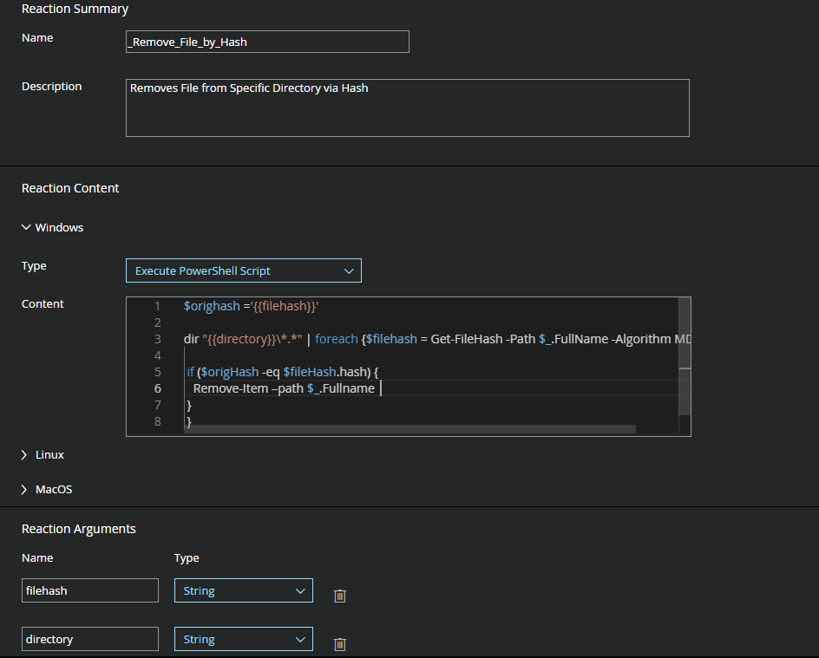

**Executing this Reaction**

Perform a “realtime” search to identify target machines to delete files by MD5 hash.

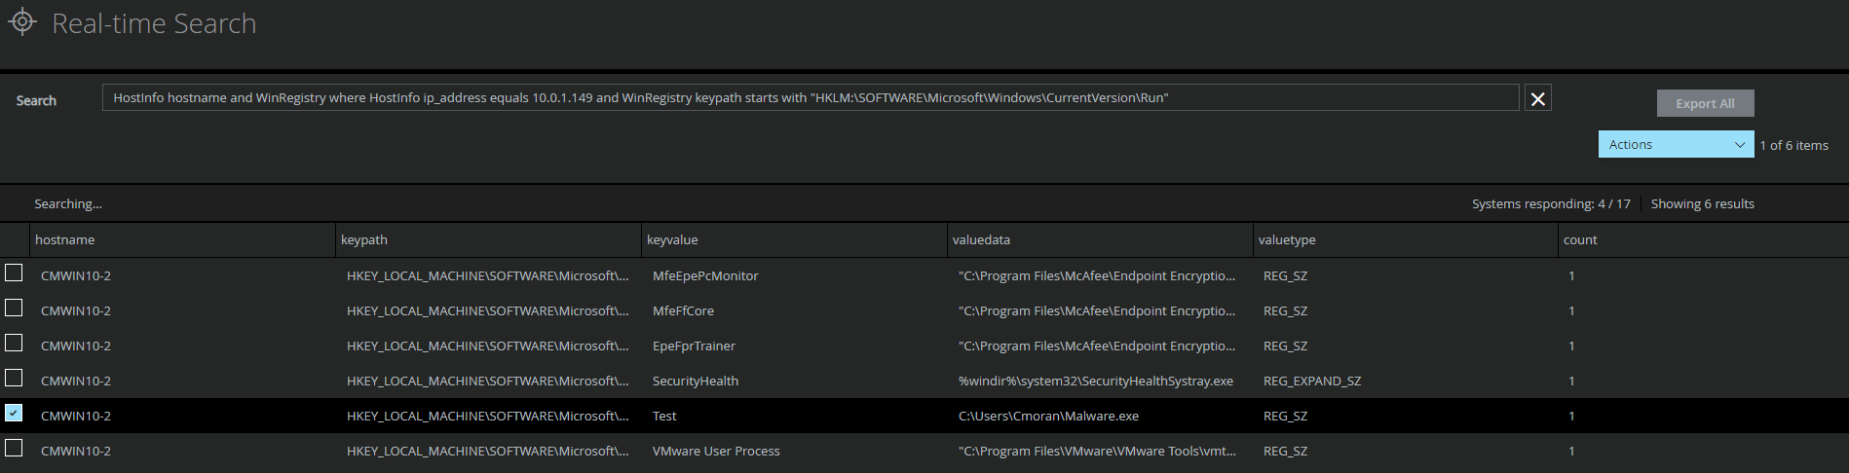

Select the desired machines and enter File hash and Path to search for the file. (Please chose as specific as a path as possible, PowerShell will search every file in the location for matching hashes)

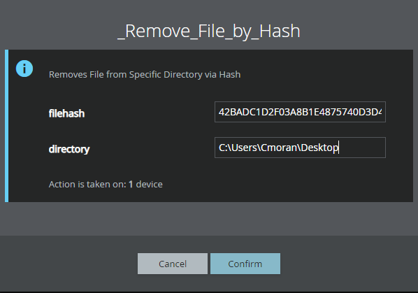

Any files matching the Target Hash will be deleted.

